**Office Attendance Guidelines**

RTO Pilot

# Effective date: November 1st 2021



The health and wellbeing of all Wizeliners is our priority. We will continue to do our best to mitigate health risks to our employees. We have created this pilot stage to help us develop our strategy for reopening our facilities. Your participation in this pilot will be voluntary and carefully planned.

We will follow strict sanitary guidelines throughout the pilot’s duration. We are modifying our designated office spaces to accommodate all participants and ensure proper social distancing to reduce the spread of germs and help us concentrate our cleaning efforts to maintain a sanitized workspace.



During the pilot, we will closely monitor the status of the pandemic. Remote work will continue to be our work modality for the majority of employees.

|  |  |
| --- | --- |
|  | **Important:** Employees who are sick (or starting to feel sick) please avoid coming to the office and seek medical help. |

Copyright © 2020 Wizeline All rights reserved.

Privileged or confidential information may be contained in this document and may be subject to legal privilege. Access to this document by anyone other than the intended is unauthorized. The content of this document is for informational purposes and subject to change without notice. No part of this publication may be reproduced, stored, or distributed without prior written permission of Wizeline.

# Authorized Work Zones

The authorized work zones are intended for people who will be attending the office on a regular basis as part of the pilot. During this period, they must work in the designated communal workspaces. Please avoid the use of other areas.

## GDL

* **Working Space**

6th floor in the A, B, C, E desks at any desk without the “Out of service” sign. Authorized Work Zones shown on the map highlighted in green.

* **Meeting Rooms**

These are the designated meeting rooms: Jackson, Icaza, Iribe, Irwin, Ising 6th floor (meeting room). With half capacity in each room. Authorized Work Zones shown on the map are highlighted in green.

* **Additional Working Space**

The temporary work zone is on the 6th floor in the D area. Work Zones shown on the map are highlighted in yellow. This is the designated area for Wizeliners who are not participating in the pilot but need to use our facilities due to an emergency situation, e.g., an internet or power outage at home.

* There will be areas assigned in the 5th Floor if you need to attend the office for People Ops or IT support.
* If you don’t need a desk to work please free up the one the app assigns you automatically.

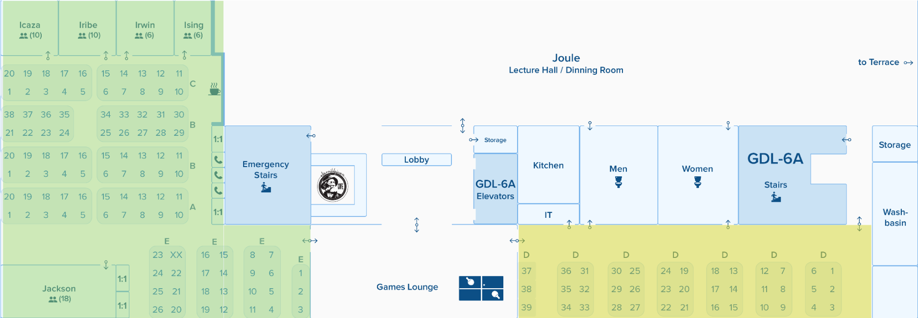

## CDMX

* **Working Space**

Desks facing the “Angel of Independence” view and the working space near the Wellness Room facing the “Glorieta de la Palma” view. Use any desk without the “Out of service” sign. Authorized Work Zones shown on the map are highlighted in green.

* **Meeting Rooms**

These are the designated meeting rooms: Newton, Markov, Maxwell, Miramontes, and Marx. Each meeting room is limited to half capacity. Authorized work zones shown on the map are highlighted in green.

* **Additional Working Space**

Desks behind the reception area. This is the designated area for Wizeliners who are not participating in the pilot but need to use our facilities due to an emergency situation, e.g., an internet or power outage at home. Work Zones shown on the map highlighted in yellow.

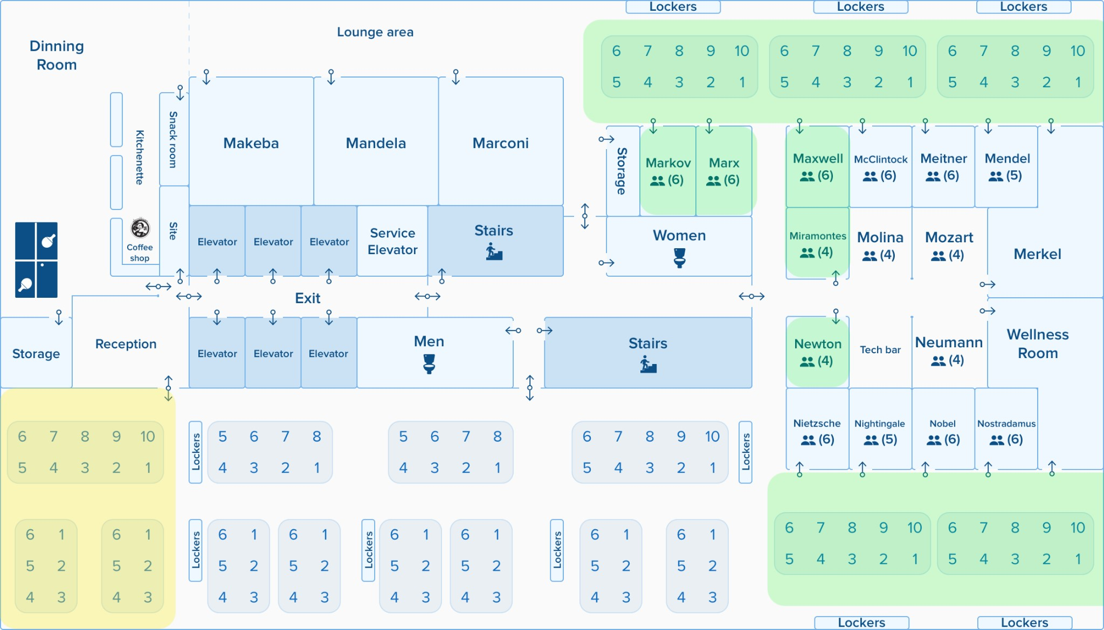

# Guidelines

To maintain a safe working environment for you and the rest of the Wizeliners working in the office we expect all participants to follow these guidelines:

* Present your official certificate of full COVID-19 vaccination.
* We will be taking temperature
* We will have a Doctor available on premises.
* Every two weeks, a lab will perform an antigen test to a randomly selected 20% of the people at the office as it is required by the government. The test results will be confidential. The test will take place in every office; in CDMX at the Wellness Room and in GDL at the Medical Services 4th floor.

Procedure if a test result is positive.

○ Wizeline will cover the test expenses for these cases.

* Everyone must do a self-check of temperature and take antibacterial gel with 70% alcohol at the entrance.
* Masks must be worn at all times while in the office and should cover both your nose and mouth.
  1. Except while eating lunch or breakfast in the dining room.
* Maintain a 4-5 ft spacing between yourself and your coworkers.
* Wash your hands frequently and wipe down your working space before and after your workday.
* We will not have catering service, so please plan accordingly.
  1. The only permitted area for consuming breakfast/lunch/dinner is the dining area.

○ Snacks and beverages can be consumed at your working area, but make sure to clean after yourself.

○ If you bring homemade meals, you can use the fridge and microwave, but please bring your own dishware and cutlery (fork, spoon and knife).

○ If you use cups and glasses, please leave them in the washing area.

○ Fridge will be cleaned every day by the end of the day. Do not leave any food or containers at the office when you leave.

* No external visitors are permitted.
* The cleaning crew will be constantly sanitizing and cleaning these designated spaces in the office.

|  |  |
| --- | --- |
|  | **Tip:** Follow the latest recommendations and findings about COVID-19 on the [WHO’s](https://www.who.int/health-topics/coronavirus#tab=tab_1) [web](https://www.who.int/health-topics/coronavirus#tab=tab_1) [page](https://www.who.int/health-topics/coronavirus#tab=tab_1). |
|  | **Important:** Work From Home is reinforced as our primary work modality during COVID-19. |
|  | **Important:** The use of face masks is mandatory to access the building. |

# Safety measures

## Procedure in case we have a positive test result at the office

* If we have a positive test result, we will proceed to close the facilities for that day and sanitize the areas where this person was.
* Contact all the people who had contact with the person
* Send those people to continue working from home and, five days later, ask them to perform a Antigen test.
* If the test result is negative you can come back to the office to work.
* If the test result is positive you will remain at home and come back until you present a negative test result.

# Process to access CDMX and GDL Offices

To help us maintain a safe office and ensure those who come can keep a safe distance from others, all employees will now need to check in using Envoy before visiting the office.

**FIRST TIME REGISTRY**

1. Download the ENVOY mobile app on your phone. [(Apple](https://apps.apple.com/us/app/envoy-your-workplace-app/id983102576) [App](https://apps.apple.com/us/app/envoy-your-workplace-app/id983102576) [Store](https://apps.apple.com/us/app/envoy-your-workplace-app/id983102576) or

[Google](https://play.google.com/store/apps/details?id=com.envoy.app) [Play](https://play.google.com/store/apps/details?id=com.envoy.app) [Store](https://play.google.com/store/apps/details?id=com.envoy.app).)



1. Sign up using your Wizeline email address.

a. Inform IT in case you are not able to log in.

1. Confirm your email address by going to your inbox.
2. Once you are registered in the app, select your office location. (Guadalajara or Mexico City, right now is not available for Queretaro)

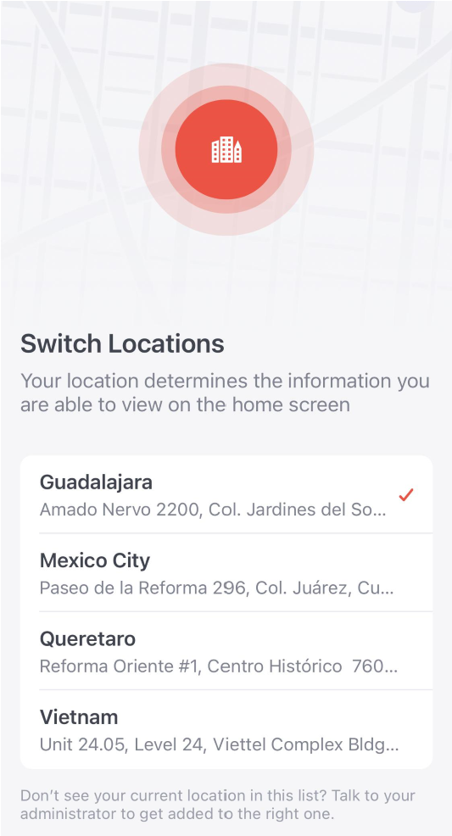

**REQUEST ACCESS, REGISTRY**

1. On the day before you plan to come in, open the app. You should see a card that says “Reserve a spot in the office” with tomorrow’s date. Tap the button that says “Register” and answer the health questions that follow.

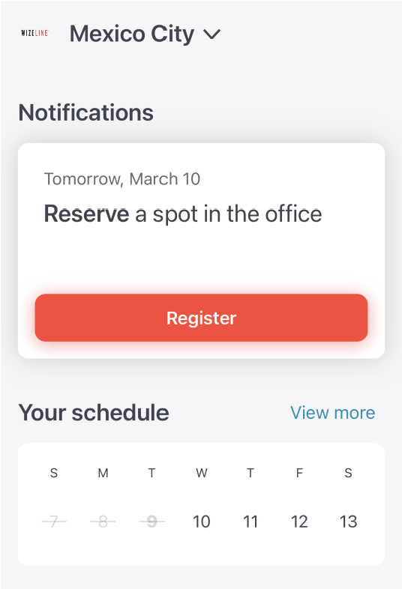

1. You will know instantly if you are approved to come to the office. Your access might not be approved in case you indicate you have symptoms or if the office capacity reaches the limit permitted.

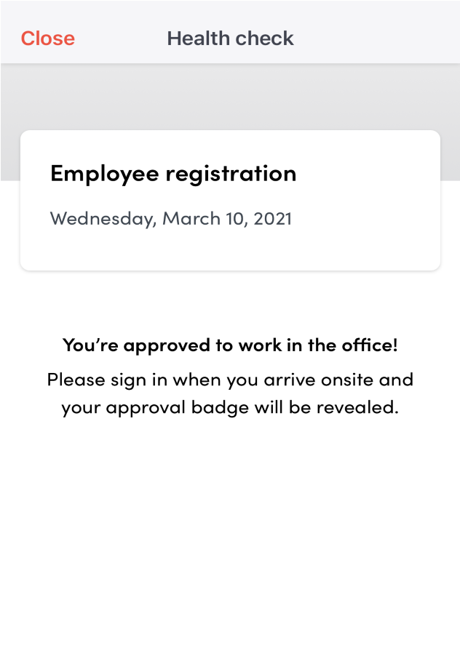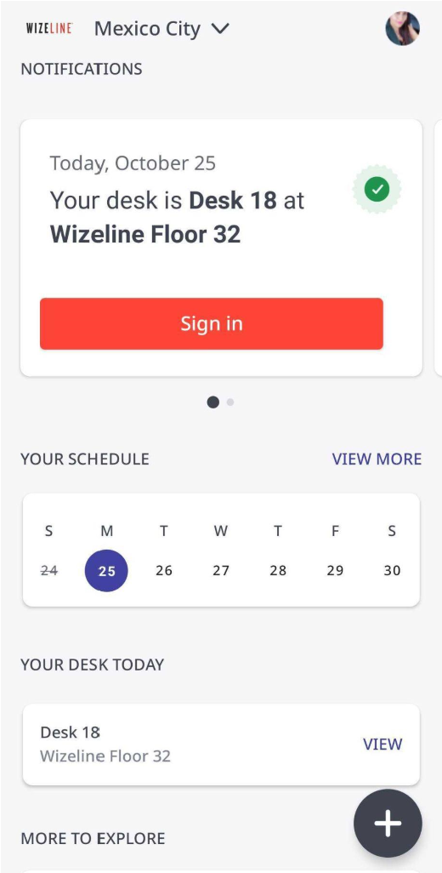

1. A desk will be assigned to you but you will be able to switch it for another. Click on SIGN IN in order to see the desk map. Click on CHANGE DESK to select a different desk.

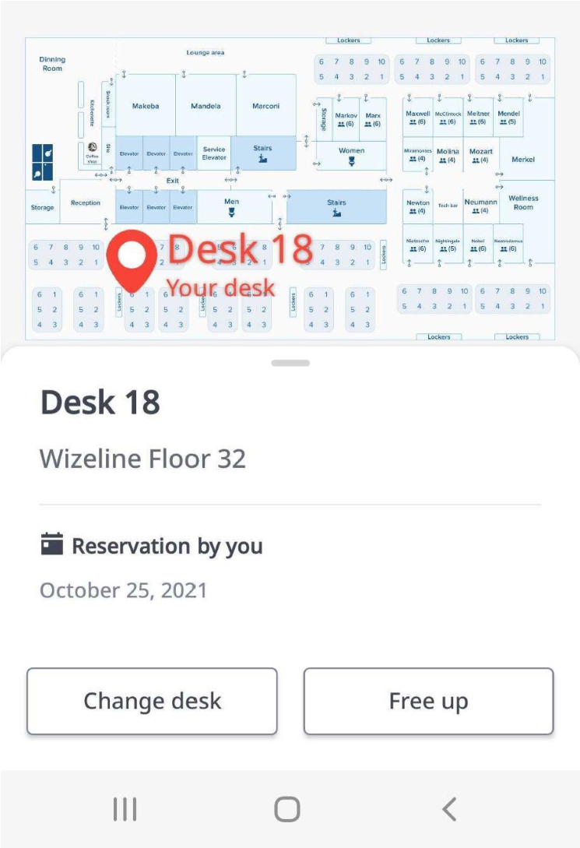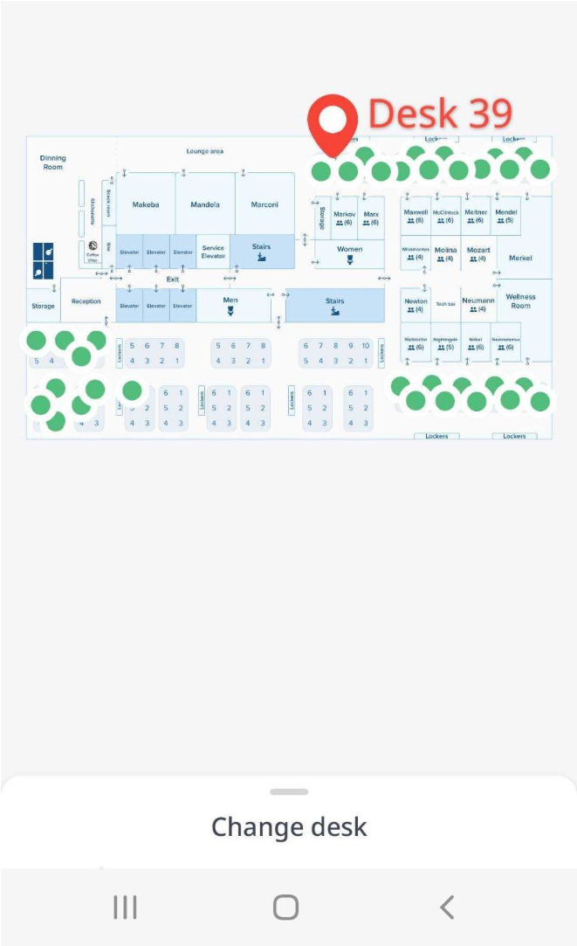

1. Once you have selected another desk click on CONFIRM to select

your new desk.

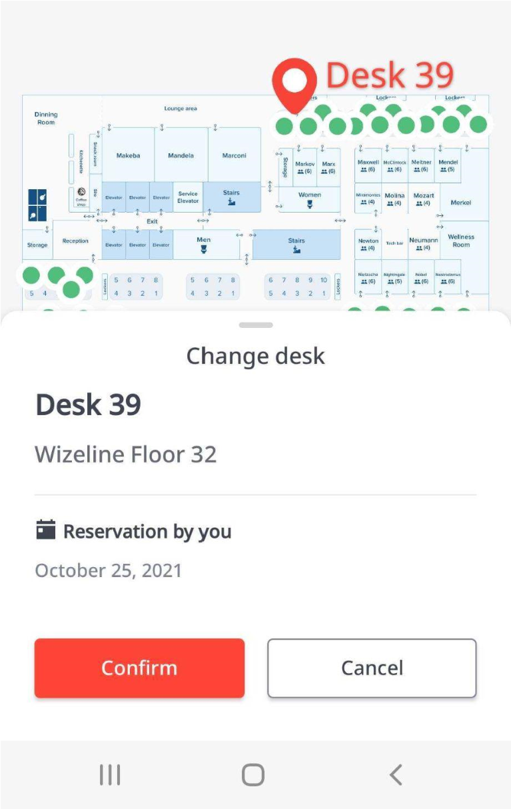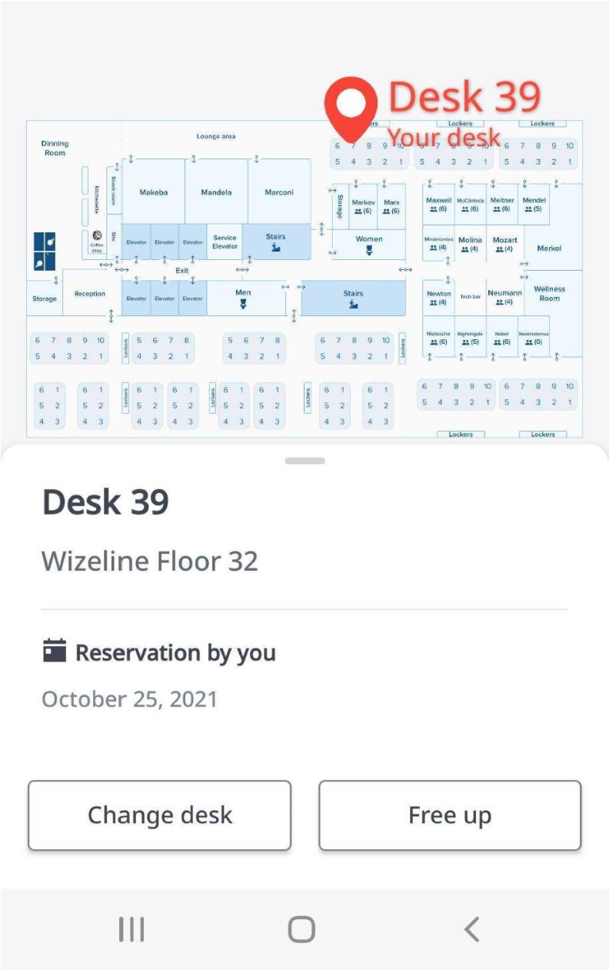

1. You can book for more than one day if you need to, go to the “Your schedule” section, tap “view more” and select the days you will require access to the office.

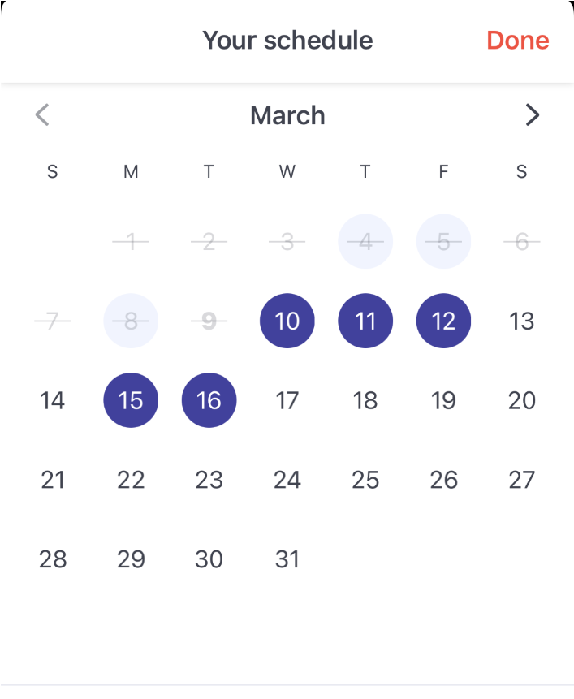

1. Sign-in will be available on the day that you reserved.

a. When you arrive at the office, open the mobile app, and tap the card that says “Approved to work in the office.” “View pass” that way you will “Sign in”.

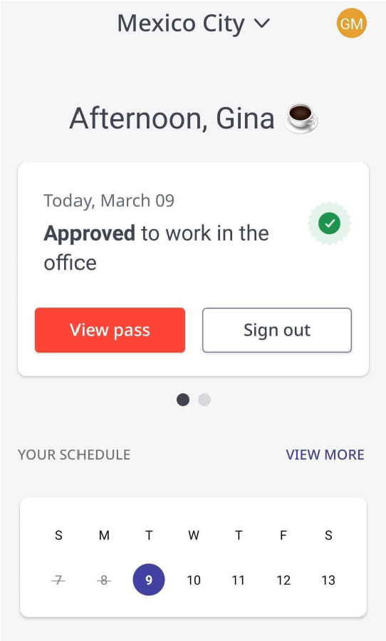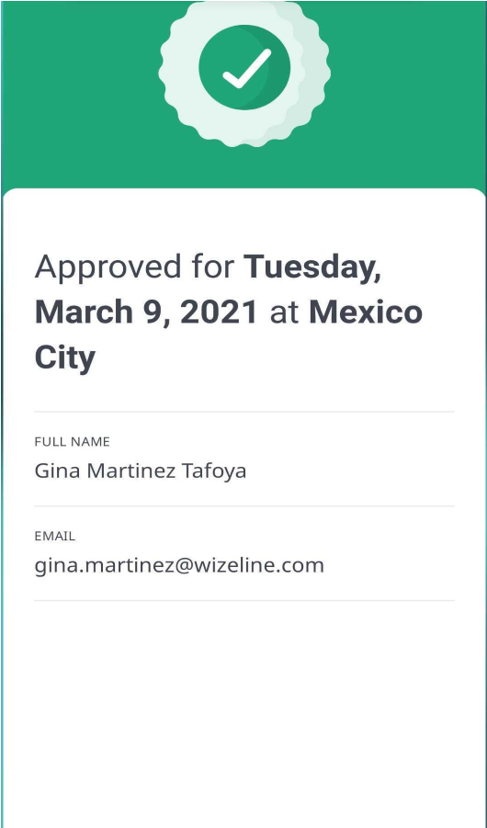

1. Before you leave the office, open the app and tap “Sign out.” This helps us know how many people are in the office at any one time.

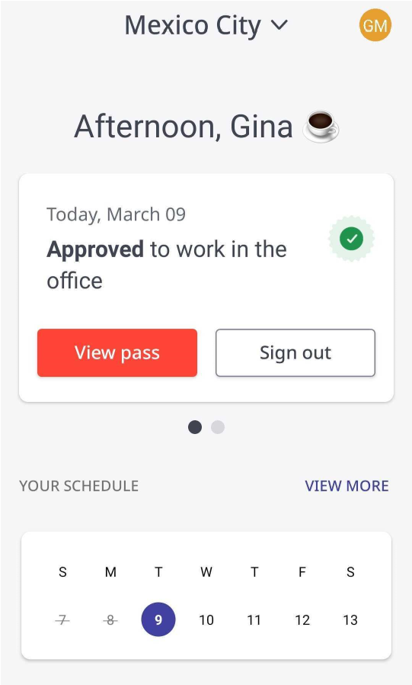

**WHAT TO DO IN CASE MY ACCESS IS DENIED**

1. If it is not safe for you to come to the office, depending on your health check, the app will show you the following message (below), for more information contact facilities-mx@wizeline.com.

